Contents
- Foreword
- Highlights
- Education and Engagement
- Our Values and behaviours
- Annual survey
- Trustee Recruitment
- Our Staff Networks and Inclusion Champions
- Anti-racism
- Gender Pay Gap
- Diversifying our communities against arthritis
- Our Commitments
- Policy, Public Affairs and Engagement
- Looking ahead and getting better

Foreword
I am delighted to share Versus Arthritis’ Diversity and Inclusion Annual Report for 2022-23. This is my second year as CEO of Versus Arthritis and I am delighted to see the progress we have made with our diversity and inclusion work and the plans for the year ahead. We have worked hard to ensure that all our staff understand the importance of diversity and inclusion and this was evidenced in our annual survey results which saw all answers for diversity and inclusion increase. I have attended many of our diversity and inclusion events throughout the year which have supported colleagues to further develop their understanding of diversity and inclusion topics and importantly develop their empathy around individuals experience the world around them. We have achieved Disability Confident Employer status, trained our staff in disability awareness training, reduced our gender pay gap and significantly diversified our Trustee Board. We have also worked with colleagues to embed diversity and inclusion in our planning, annual reviews and over the next 12 months we will be looking at embedding diversity and inclusion practice into our project management.
I am proud of the progress we have made in the past 12 months but I do not underestimate the challenges we face in achieving a future free from arthritis for everybody, regardless of their background. The chronic pain of arthritis can lead to isolation, depression and increasing poverty and if you are economically poor, you are more likely to develop arthritis ten to fifteen years earlier than if you are affluent and to be living with multiple long-term conditions. We know that nearly half of women living in the most deprived parts of society report chronic pain, and some ethnic groups are more likely to have a musculoskeletal condition or to experience chronic pain than others, and their health outcomes are often worse. Our organisational strategy that we have recently launched will support us to focus on partnering with organisations that work within underserved communities so we can extend and diversify the reach and impact of our services, ensuring identified unmet needs inform our research agenda and the support we provide.
All our people are fully behind our plans to diversify our communities against arthritis because they worked with us develop our vision, mission and goals. I am excited by what we can achieve as One Versus Arthritis and look forward to sharing our diversity and inclusion progress in the future.

Highlights
We have been busy continuously refining our approach to diversity and inclusion, learning what works and what needs more development through engagement with our people and diversity and inclusion best practice and research.
- Reflecting our commitment to putting diversity and inclusion at the heart of everything we do at Versus Arthritis, we increased our internal resource and appointed a Diversity and Inclusion Business Partner.
- We moved Involvement into the Diversity and Inclusion team with the specific goal of diversifying the Involvement Network to ensure we are engaging with a diverse range of people with arthritis and amplifying their voices to help us achieve our vision of a future free from Arthritis.
- Hosted the Diversity and Inclusion Practitioner’s Network of over 100 charities, demonstrating our commitment to working across the sector, sharing best practise and challenges to progress.
- We launched Versus Arthritis’ first anti-racism action plan that includes our statement on anti-racism and sets out what it means to be anti-racist in Versus Arthritis.
- Celebrated Black Inclusion Week for the first time with plans to celebrate every year.
- Worked with Diversifying Group to recruit new Trustees including our Chair, resulting in significant diversification of the Trustee Board.
- Embedded diversity and inclusion into directorate plans and individual objectives.
- Established Involvement Network Diversity and Inclusion Action Group, a group of people with experience of arthritis, who support Versus Arthritis to progress its Diversity and Inclusion goals.
- Delivered a calendar of diversity and inclusion events, with excellent feedback and an appetite from our people to continue developing their understanding on diversity and inclusion topics.
- Worked with Diversity and Ability, an award-winning social enterprise led by and for disabled people to train the workforce in disability awareness.
- Achieved Disability Confident Employer status.
- Agreed Versus Arthritis’ Welsh Language Scheme, Welsh Language Developmental Plan and established a cross organisation Welsh Language Group to scrutinise progress of the scheme and plan.

Education and Engagement
In 2022 we increased our education and engagement at Versus Arthritis, celebrating inclusion events including Black History Month, South Asian Heritage Month, LGBT History Month, Neurodiversity Celebration Week and Endometriosis Awareness Day. We also launched twice monthly ‘lunch and learn’ sessions that covered a diverse range of topics including men’s mental health, World AIDS Day and ‘Seasonal Stories, Traditions and Festivals’. As part of National Inclusion Week, all staff were invited to attend menopause training with Henpicked. We also partnered with Lupus UK as part of Black History Month and engaged in an external event with a Facebook Live and an internal engaging with a case study on Living with Living Lupus.

Some of the feedback from our events:
‘I think it's really amazing that we are looking at Neurodiversity. As someone who has people within her family who have Autism I found this session so valuable (and quite emotional!). I think the more of these sessions we can do the better. Thanks for the amazing work you're doing as a team’
‘Very interesting, learnt lots and enjoyed the presentation style, quiz, friendly, accessible presenter’.
‘Really glad we had this session and just giving some time and space to talk about women's heath’.
‘Personally, I am experiencing a wide range of peri-menopausal symptoms and they can be very overwhelming sometimes so want to ensure everyone feels supported in the best way we can at VA. Thanks again for the excellent session and for everyone's engagement’.

All new staff at versus Arthritis attend a mandatory Diversity and Inclusion workshop which explores the definitions of equality, equity, diversity and inclusion, the benefits of a diverse charity and an inclusive culture. The workshop also covers the challenges for progressing diversity and how we can be more aware of individual and systematic bias and blind spots that prevent the progression of diversity and inclusion at Versus Arthritis. New staff also attend self-directed anti-racism training that combines expert recorded dialogue with an anti-racism expert who guides staff through the many facets that make up anti-racist thought and behaviour.

Some of the feedback
‘The workshop was well presented and although I feel I have a knowledge of this subject already, I did learn some new things. Thank you’.
‘Whilst it was not necessarily new information, it was communicated in an engaging and interesting way and is always a helpful challenge to ensure that we are putting EDI at the fore front of our work’.
‘Great foundation to start never ending journey to question, reflect and improve how we work and engage with others’.
We were also delighted that all staff at Versus Arthritis attended 3 hour training with Diversity and Ability. The training aimed to improve knowledge and understanding of disabilities and the prevalence of both visible and invisible differences in the workplace. The training highlighted small changes that help to create an inclusive culture where everyone can thrive and is part of our journey to achieve Disability Confident Leader.

Our Values and Behaviours
Versus Arthritis’ new set of values and behaviours was developed over eight months and with much consultation. Research to underpin the first draft included:
- 9 stakeholder interviews with senior leaders,
- a culture survey in June and July through which 455 volunteers, staff and people with arthritis responded
- 22 focus groups in July and August comprising 478 attendances from staff, volunteers and people with arthritis.
- 140 feedback responses through our Involvement Network.
As the only national arthritis charity, we are unique and ambitious in seeking a 'future free from arthritis'. With our drive to improve the experience of those we support firmly at our core, we stand united, acting with compassion, demonstrating inclusivity and bravery in all that we do:

United ​
​We unite as a community to ensure better outcomes for people with arthritis now and long into the future. We strive to increase access to support and treatment whilst using our expertise to further research into prevention and cure.​
​
Collaborative: we connect, building partnerships to deliver ​better impact and sustainability.​
Passionate: we are advocates, strong and united we make ​a difference for and with people with arthritis.​
Celebrate: we come together as one team to celebrate ​successes big and small, valuing the part that​ everyone plays.

Compassionate​
​We truly care about people with arthritis, they are at the heart of everything that we do. We work hard to understand everyone's experiences, challenges and needs to ensure the best support, advice, information and action to help people live well with arthritis.​
​
Empathetic: we actively listen in order to understand and take action.​
Caring: we care about each other and people with arthritis and always try to make a positive difference.​
Supportive: we support and consider each other's wellbeing in everything we do.

Inclusive​
​Our variety of knowledge and experience helps us to succeed. We aim to represent the communities we serve. Valuing and respecting different views and diverse perspectives, creating accessible ways to participate and contribute meaningfully.​
​
Authentic: we welcome and encourage diversity of knowledge, thought, experience and expertise, celebrating what makes us unique.​
Respectful: we make our voice heard, valuing others and challenging considerately.​
Fair: we champion equity and fairness every day.

Brave​
​We use evidence and expertise to challenge inequality and drive change. Being brave, owning our decisions and actions to stand up for people with arthritis whilst working towards prevention and cure.​
​
Bold: we drive change, using evidence and our expertise to stand up for what is right, driving solutions focused action.​
Curious: we learn from everything we do, staying curious in exploration, whether we fail or succeed. ​
Accountable: we make an impact and get things done, communicating transparently and owning our actions and decisions.

From 2023, we will progress the wider integration of our values and behaviours into all of our work, examples include our new appraisal process, policies, email footers, narrative and discourse. As our culture is strengthened and aligned to our new values and behaviours, the benefits will be felt by all of our people.

Annual Survey
In October 2022 Versus Arthritis performed a People Survey across its employees and achieved a response rate of 72% (205 staff members). The survey focused on three key areas:

- Employee engagement
- Wellbeing
- Diversity and inclusion

Employee engagement has increased overall (up two percentage points compared to results in 2021, from 65 to 67). Colleagues feel prouder and more likely to recommend Versus Arthritis as a place to work than they were in 2021, as well as more inspired to do their very best.
Improved shared understanding increased shared understanding of diversity and inclusion (17%), anti-racism (23%) and disability inclusion practices (39%) sets a strong foundation for an overall improvement in this area, with all questions asked in this section in this year, scoring better than they did in 2021.
However, when compared to sector averages, our scores still show room for improvement:
- People who work for and with VA are treated equally irrespective of ethnicity, gender, disability, age, sexual orientation or religion: VA score: 70% positive, up 20 points from last year, but still 16 points below the sector average.
- I am treated with fairness and respect at VA: VA score: 79% positive, up 1 point from last year, but still 7 points below sector average.

The scores for the shared understanding of diversity and inclusion at Versus Arthritis can be attributed to the mandatory workshop and training and also the 12 month calendar of events. We understand that we need to undertake further work in this area, particularly on revising our people policies and there is a timetable for this important work. We also plan to revise our diversity and inclusion action plan to align it with our organisational strategy, ensuring that all activity progresses internal and external diversity and inclusion goals.
Trustee Recruitment
We were delighted to be able to share with you details of our new Chair and six new Trustees who were elected to the Board at the end of the December Board meeting. Their appointment was the culmination of a long recruitment campaign led by the Board themselves with the support of diversity and inclusion specialists, Diversifying Group.
Kate Tompkins has been appointed as our new Chair of Trustees. Kate has extensive experience in integrated person-centred care and support, having worked in the community and as a Chief Nurse and Chief Executive in the NHS and as CEO of Cavell Nurses Trust charity. Kate has also a great deal of experience as a trustee and Chair at several charities including the Royal Osteoporosis Society, Dorothy House Hospice Care and Hospice UK. Kate has a particular interest in supporting people with long term and life limiting conditions in their own home and community, and enjoys the odd game of walking netball and golf.
Almost all of our new trustees have a personal connection to arthritis, whether with a diagnosis themselves, or a very close family member. One of our key objectives during this recruitment process was to diversify the Board to better reflect the experiences of people with arthritis. Our new trustees range in age, gender, and ethnic background, some have been trustees before, others have not. Some have been volunteering with us for a long time, and others are completely new to the charity bringing a diverse range of expertise and experience to support our future development.
Our plans for 2023/24 include benchmarking current practice against the Charity Governance Framework (diversity and inclusion) to support Trustees to have a clear, agreed and effective approach to supporting diversity and inclusion throughout the charity and in its own practice. This approach will support good governance and the delivery of the organisation’s charitable purposes.

Our Staff Networks
We have 4 Staff Networks at Versus Arthritis:
- Race Equity Network
- Disability and Inclusion Network
- LGBTQ+ Equality Network
- Women’s Network
The networks have represented their members in the Diversity and Inclusion Action Group, chaired by our CEO, Deborah Alsina and provided feedback for all our diversity and inclusion work. Thank you to all our Staff Network members and we look forward to building on your successes in 2023/24.

Inclusion Champions
We want to put diversity and inclusion at the heart of everything we do at Versus Arthritis so that everyone will feel they can belong to the Versus Arthritis community and feel comfortable and valued in bringing their whole self to our charity. Over 30 Inclusion Champions help us to continue to build our network of people who are actively progressing our diversity and inclusion strategy goals in their work by:
- Actively encourage conversations about diversity and question the way we do things.
- Promoting, celebrating, and raising awareness of diversity and inclusion within their team.
- Role Modelling inclusive behaviour.
- Keeping colleagues up to date with our diversity and inclusion news and events.
- Continuously learning about diversity and inclusion topics.
- Creating a ‘safe space’ in which Inclusion Champions can share their experiences and make suggestions on how to further progress diversity and inclusion across Versus Arthritis.
- Attend monthly meetings.

Thank you to all Versus Arthritis’ Inclusion Champions who continue to help us progress our diversity and inclusion goals.

Our Menopause Support Group
The majority of our staff at Versus Arthritis are women aged between 35 and 54 which means a high percentage will be experiencing perimenopause and menopause. Menopausal women are the fastest growing demographic in the workforce and almost eight out of 10 of menopausal women are in work. We are proud to have set up a Menopause Support Group and developed Menopause Guides for Staff and Volunteers and Line Managers. We also have an in depth set of menopause resources available to all staff. The Menopause Support Group supplies items for ‘emergency menopause kits’ in our offices across the four nations ‘because these things happen’. We are also members of Henpicked and will be applying for ‘Menopause Friendly Employer’ status in 2023. We are also signatories of the ‘Menopause Workplace Pledge.

Anti-racism
In April 2022 we launched our anti-racism statement and Zoe Chivers, Director of Services and Influencing, became Versus Arthritis’ anti-racism sponsor. 89% of staff have completed anti-racism training, either face to face or self-directed learning and there is a library of anti-racism resources available to all staff. The resources are regularly advertised in our internal communications and the organisation shared understanding of anti-racism increased by 23% this year. We now need to build on these foundations and ensure our organisation’s shared understanding of anti-racism in embedded in our planning, delivery and behaviours. We will update our anti-racism action plan so that it is aligned with our organisational strategy.

Gender Pay Gap
We are pleased to report that our gender pay gap remains well below estimated UK averages of 13.9 for the mean and 14.9 for the median. Our 2022 mean gender pay gap is 4.3%, and our median pay gap is 6.6%. Our mean gender pay gap has increased slightly (+1.5%) on last year, and our median gender pay gap has reduced by 2% evidencing a downward trend over the past four years. The mean is defined as the average whilst the median is the mid-point.
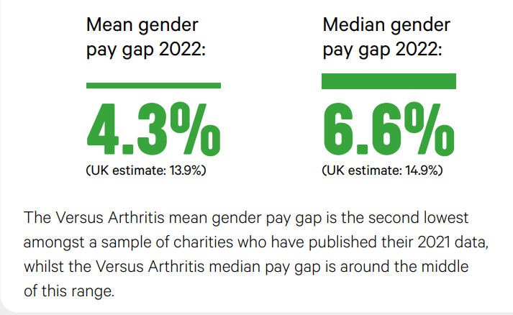

Our progress and next steps
- We launched our Versus Arthritis approach to recognition and reward, ‘The Power of One’, in June 2020. This provides a framework for celebrating everyone’s valuable contribution towards achieving our ambitions as well as recognising and celebrating personal achievements and service. This change has significantly impacted on the bonus payments made. With single value awards, the bonus pay gap has reduced to zero this year.
- We have created a new Women’s Network to share experiences, careers advice and information. The Network is providing us with a mechanism to understand the female perspective, better support females in the workplace and to inform policy and decision-making.
- We have introduced a new exit interview survey process to better understand our turnover. This includes a new platform to improve the collection of data and enable greater insight into the reasons for turnover, identification of trends, and inform policy and working practices.

Diversifying our communities against arthritis
We have made significant progress in the diversity of our Trustee Board and we are proud of this progress. However, we have not made the progress in the diversity demographics for staff and volunteers, although we are much better at understanding the importance of collating diversity demographic data to make data led diversity and inclusion decisions and planning.

With the introduction of a new HR system and applicant tracking system, we will be able to better understand the diversity demographics of applicants, who is progressing through our recruitment process and how we can upskill our recruiting managers to appeal to a diverse group of potential new employees and volunteers.

Our Commitments
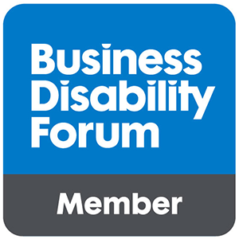
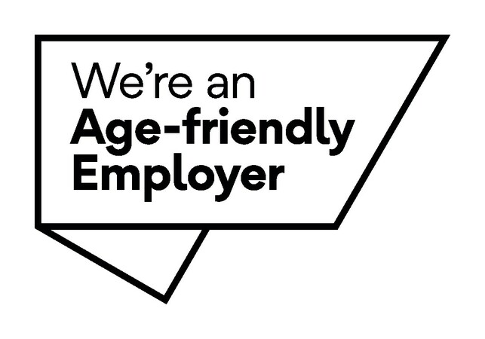

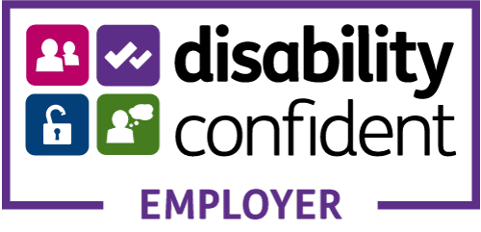
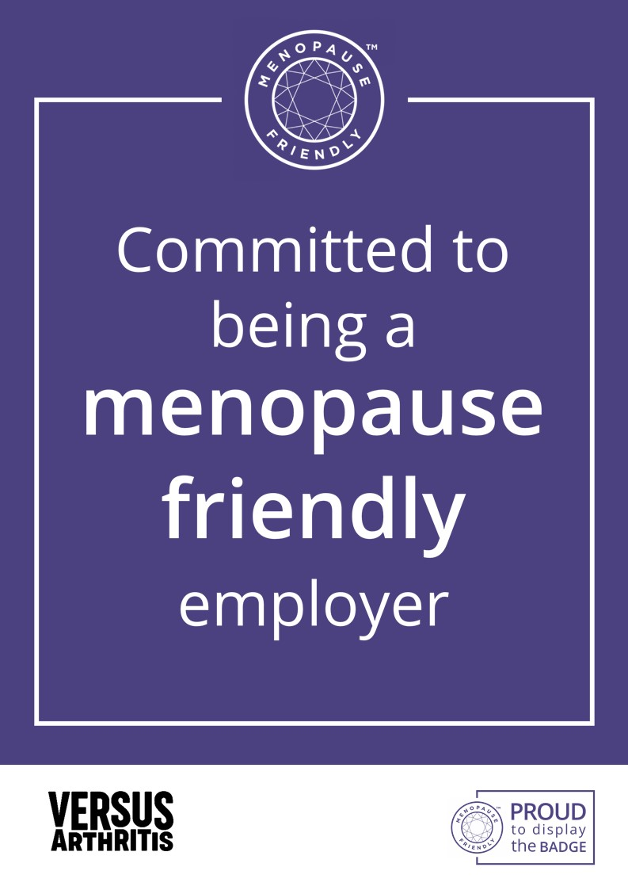

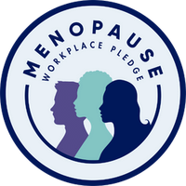

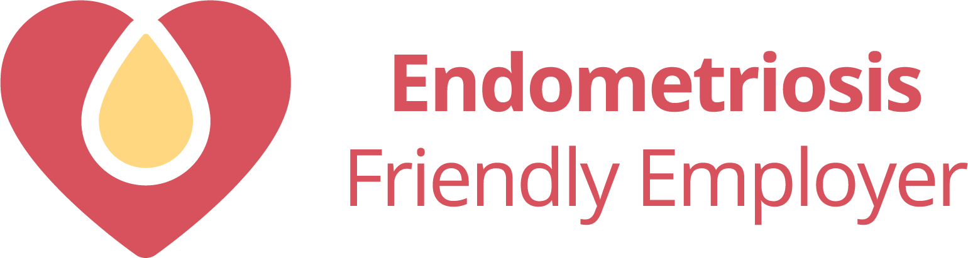
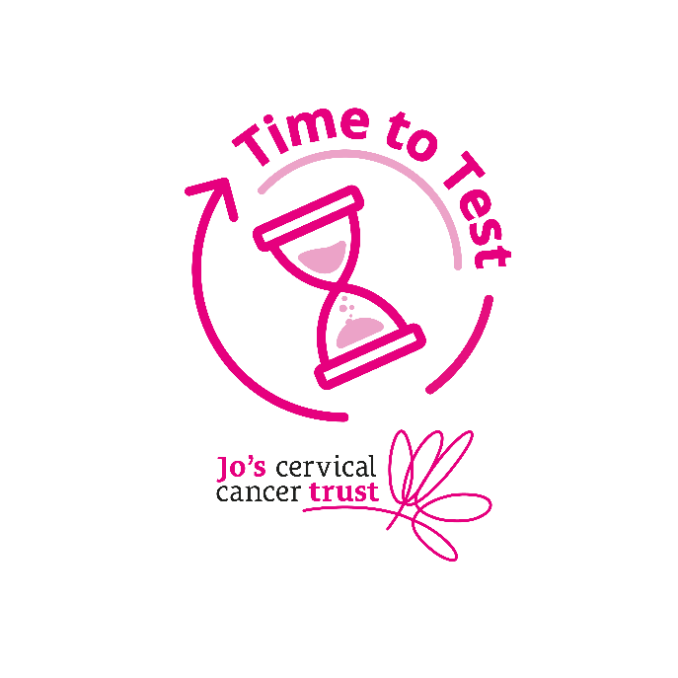

Policy, Public Affairs and Engagement
Over the last year Versus Arthritis has carried out a number of activities focused on highlighting health inequalities and exploring potential solutions.
Written evidence
In the last year Versus Arthritis’ Policy and Public Affairs team has submitted written evidence into a number of inquiries exploring health inequalities, representing the needs of people with arthritis and MSK conditions. This includes contributing to the All Party Parliamentary Group on Medical Research’s inquiry and report Health Disparities: Why Medical Research is a Crucial Tool for Change[i], and the Arthritis and Musculoskeletal Alliance’s inquiry into MSK health inequalities.[ii]

Inequalities in Health Alliance
Versus Arthritis is a member of the Inequalities in Health Alliance, a coalition of organisations convened by the Royal College of Physicians campaigning for a cross-government strategy to reduce health inequalities.

In July 2022 Versus Arthritis was one of 47 signatories to a Health Disparities White Paper Consensus Statement, which highlights that long-term cross-Government action is required to truly tackle the root causes of ill health strongly linked to health inequalities.[iii] The statement asserted that this should be underpinned by a cross-Government strategy to reduce health inequalities that considers the role of every Government department. We have urged the Government to maintain a commitment to address health inequalities.

Work with Gypsy Traveller communities
The Versus Arthritis Pain People Place project is a rolling programme of engagement activity focused on lived experience of chronic MSK pain across communities in Scotland, including the impact of rural or remote living on the experience of chronic pain. Versus Arthritis has been working on engagement with Gypsy Traveller communities through this project. Focusing on principles and practices of engagement, the project is exploring how a national third sector organisation learns to engage effectively with marginalised communities, to include the ‘missing voices’[iv] and hear the ‘unheard’[v], which often requires ‘more effort and creativity’.[vi] The work to date includes a Community Health Day at a Traveller site in North Highland and co-design work on a Gypsy Traveller Health Needs Assessment.

A report from the Pain People Place project was published on the rural Grampian area in 2021, and Argyll in 2022.[vii] The project recommended that clinical pathways support self-management; that social prescribing is front and centre of health and social care; that the balance of local/regional/national dimensions and the reality of how people access services and support is understood; and that capacity is grown, based on shared commitment. This area-based approach highlights local partnership working and enabled people to highlight what support they need, with the outcomes being framed around the central self-reported component of people lacking confidence due to their pain.

Research around this area
Versus Arthritis invests around £13 million in research every year, and tackling health inequalities is a central pillar of our Research Strategy for 2022/26.[viii]
The Oliver Bird fund, co-funded by Versus Arthritis and the Nuffield Foundation, aims through interrelated policy, practice, and research activities, to improve the lives of those living with the range of MSK conditions, including rheumatic diseases. The six research projects, announced in January 2023, aim to inform policy and practice responses to living and working well.[ix] A number of the projects explicitly focus on understanding disadvantage and inequality. (can provide more detail if desired)

Involvement
We regularly involve people with lived experience in our policy, public affairs and campaigning work. This includes through speaking in front of politicians at our Parliamentary Receptions, through surveys, and through campaigning actions.

Our Plans for 2023/24
Our second year with focussed diversity and inclusion resources saw us building on the foundations of Versus Arthritis’ first diversity and inclusion strategy and anti-racism action plan. The year was again challenging, with the organisation working through the implications of the organisational strategic review but even in adversity we progressed our diversity and inclusion work, recognising where we still have gaps in progress.

Accreditations
We will work towards becoming Disability Confident Leader, Visibly Better Employer, Age Friendly Employer, NIHR Race Equality Standard, Menopause Friendly Employer, Business Disability Forum Smart Employer.

Working with our underserved communities
We will work with colleagues in Services and Influencing to plan engagement with organisations in our geographical service delivery locations who work with our underserved communities to ensure a diverse and engaged involvement network.

Calendar of events
We have planned and will deliver an internal calendar of events that cover a broad range of inclusion topics and increase understanding of a range of backgrounds and experiences.

Staff Networks
We will continue to support Versus Arthritis’ Race Equity Network, Women's Network, Disability Inclusion Network, LGBQT+ Equality Network and Menopause Support Group ensuring engaging and supportive staff networks that help Versus Arthritis to put diversity and inclusion at the heart of everything we do.

Organisational Support
We will continue to provide an excellent business partnering service across all directorates based on team priorities, providing resources and toolkits and sharing good practice.

Diversity demographics
Introduce an applicant tracking system and associated resources and toolkits to ensure recruiting managers are doing everything to increase diversity. We will Benchmark current practice against the Charity Governance Framework (diversity and inclusion) and establish action plan to address gaps.

Welsh Language
We will deliver Versus Arthritis’ Welsh Language Developmental Plan to support our Welsh language Scheme.

[i] Download.ashx (amrc.org.uk)
[ii] ARMA's National Inquiry into MSK Health Inequalities
[iii] Association of Directors of Public Health (2022). Health Disparities White Paper Consensus Statement. Accessed here: https://www.adph.org.uk/wp-content/uploads/2022/07/Health-Disparities-White-Paper-Consensus-Statement_July-2022.pdf
[iv] Unwin, Meakin & Jones 2020. The Missing Voices of Disabled People in Gypsy, Roma and Traveller Communities. Project Report. Accessed here: The Missing Voices of Disabled People in Gypsy, Roma and Traveller Communities - Worcester Research and Publications
[v] Minority Ethnic Carers of Older People Project (MECOPP) (2012). Hidden Carers Unheard Voices: Informal caring within the Gypsy/Traveller community in Scotland. Accessed here: Hidden Carers Unheard Voices — MECOPP Carers Centre
[vi] Vittles cited in BEMIS Scotland (2015). How to Engage with Ethnic Minorities and Hard to Reach Groups. Accessed here: how-to-engage-em-htr-groups.pdf (bemis.org.uk)
[vii] Versus Arthritis (2022). Pain, People, Argyll. Accessed here: pain-people-argyll-report-versus-arthritis.pdf (versusarthritis.org)
[viii] Versus Arthritis (2021). Research Strategy 2022/26. Accessed here: https://www.versusarthritis.org/research/introducing-our-research-strategy/
[ix] Versus Arthritis (2023), New research to improve work and well-being for people with musculoskeletal conditions. Accessed here: New research to improve work and well-being for people with musculoskeletal conditions (versusarthritis.org)

